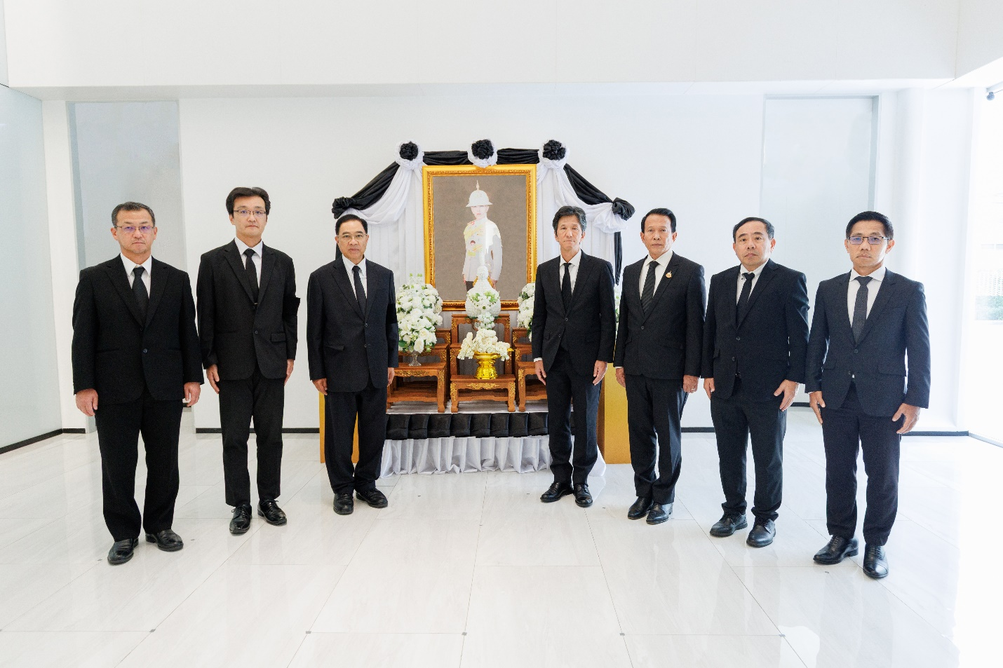
Toyota Motor Thailand Co., Ltd. held a condolence ceremony in honor of
Her Royal Highness Princess Bajrakitiyabha Narendiradebyavati Kromluangrajasarinisiribajra Mahavajrarajadhita

On June 16, 2026, Mr. Kalin Sarasin, Chairman of the Board of Toyota Motor Thailand Co., Ltd., accompanied by executives and employees, participated in a signing ceremony of condolence for Her Royal Highness Princess Bajrakitiyabha Narendiradebyavati Kromluangrajasarinisiribajra Mahavajrarajadhita in remembrance of her boundless and immeasurable benevolence. The ceremony took place at the Toyota Alive Bang Na building.

