Pricing and Campaign
TOYOTA LAND CRUISER FJ
“Bold & Unbound…Be Defined. Go Beyond.”

Standard Price 1,289,000 THB
Special Launch Price: 1,269,000 THB (Until August 2026)
Special Offers: Choose from two exclusive options:
Option 1: Special interest rate of 1.99% with Toyota Care first-class insurance coverage
Option 2 Special interest rate of 1.99% with a complimentary Genuine Toyota Accessories package*

* Choose from 3 Toyota Genuine Accessories Packages:
- The recommended retail price includes 7% VAT and excludes installation costs.
- Genuine Toyota accessories distributed through authorized Toyota dealers are covered by a warranty of up to 3 years or 100,000 km, whichever comes first (subject to specific vehicle models as defined by the Company. Please refer to the warranty booklet and owner’s manual for full details).
*For more information on warranty terms and conditions, please visit: https://www.toyota.co.th/accessories/warranty/tga

- Package 1: " Unbound Explorer… Because life means going beyond the familiar"
Value: 32,700 THB. Includes:
  - Snorkel Price 15,600 THB
  - ARB Engine Under Shield Price 8,500 THB
  - Overfender Set Price 8,350 THB

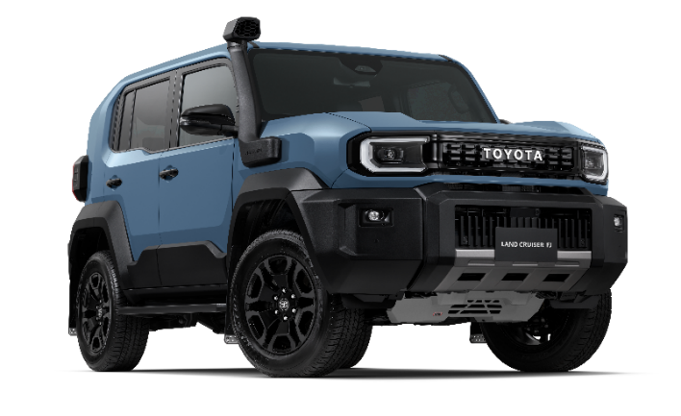
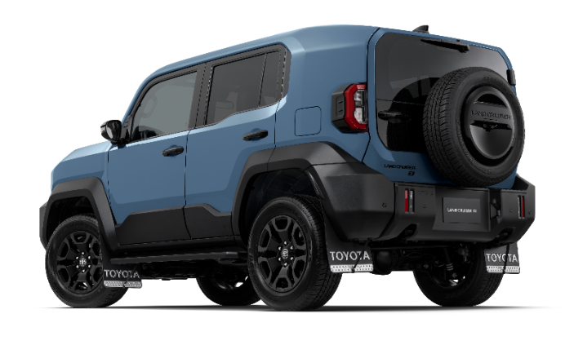

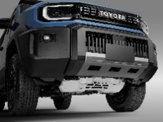
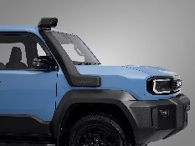
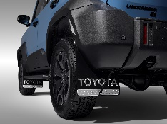
ARB engine underbody protection (skid plate)
Snorkel
Fender flares

- Package 2: “Urban Unique… Everything You Need, All in One”
Value: 32,450 THB. Includes:
  - Engine Under Guard Price 7,500 THB
  - Front Grille Garnish Price 3,400 THB
  - Door Body Molding Price 7,900 THB
  - Spare Tire Cover Garnish Price 4,600 THB
  - Fuel Lid Garnish Price 1,200 THB
  - Side Visors Price 2,100 THB
  - Digital Video Recorder (Front & Rear - 2K) Price 6.000 THB

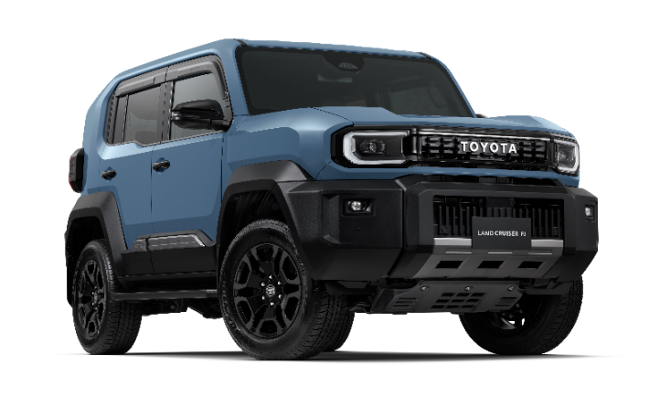
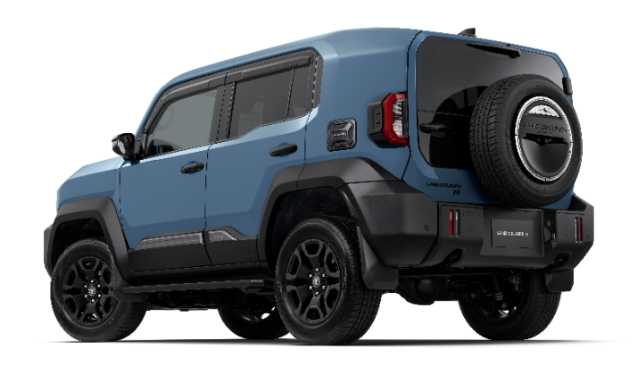
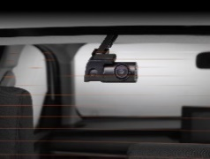
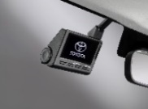

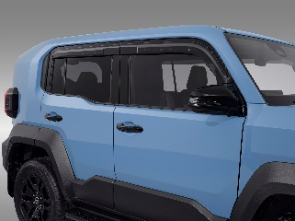
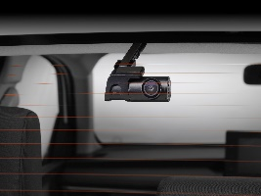
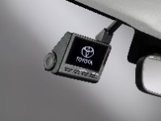
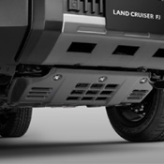
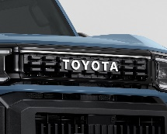
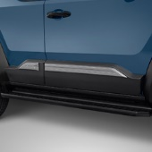
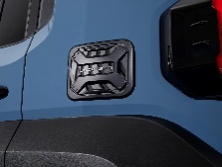
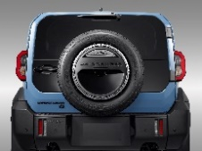

Side window visor
Underbody skid plate
Front and rear dash camera
(2K resolution)
Fuel cap cover garnish
Door protection molding
Spare wheel cover garnish
Front grille garnish

- Package 3: “Freedom Journey…Fueling every day with purpose”
Value: 36,400 THB. Includes:
  - ARB Roof Rack Tray Price 36,400 THB

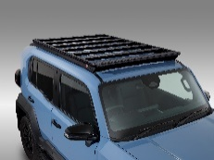
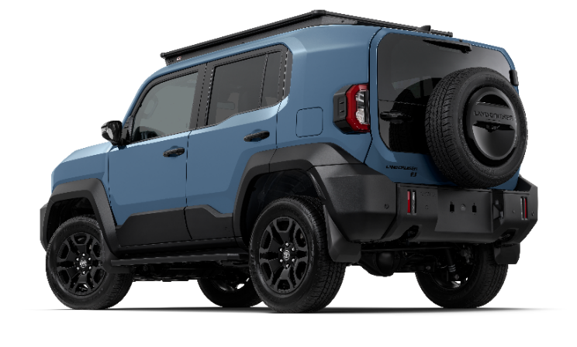
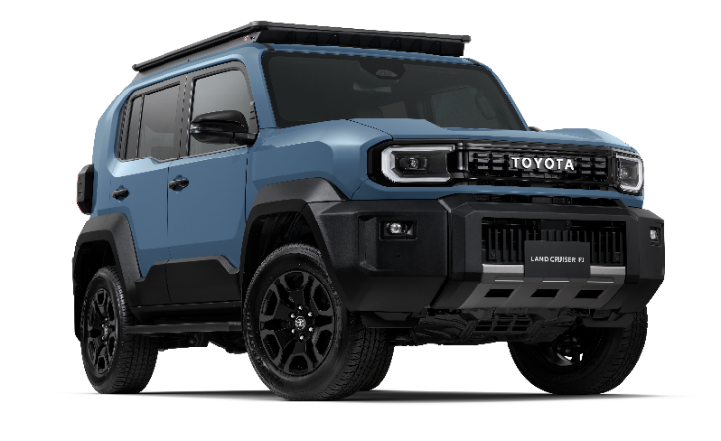

Genuine Toyota Accessories
Unleash every freedom and embrace life's challenges with the LAND CRUISER FJ — equipped with Genuine Toyota Accessories designed to support your every lifestyle, backed by a warranty of up to 3 years or 100,000 km.

Toyota elevates the spirit of adventure with the launch of Genuine Toyota Off-Road Accessories, developed in collaboration between TOYOTA and ARB, a global leader in off-road equipment. These accessories enhance the vehicle’s ruggedness, strength, and confidence under the concept “Conquer Every Terrain,” reflecting the resilient DNA of the LAND CRUISER FJ.

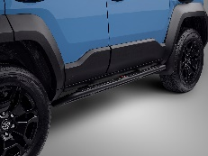
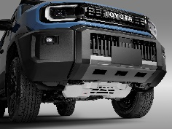
Overfender Set
ARB Rock Sliders
ARB Roof Rack Tray
Snorkel
ARB Engine Under Shield

Customize your vehicle to perfectly match your lifestyle, whether focusing on functionality or standout design, ensuring a driving experience that truly reflects your identity.

“Go Anywhere” Accessories Set: For those who push beyond boundaries.
- ARB Roof Rack Tray Price 36,400 THB
- ARB Rock Sliders Price 29,500 THB
- ARB Engine Under Shield Price 8,500 THB
- Overfender Set Price 8,350 THB
- Snorkel Price 15,600 THB
- Multi-Purpose Hook (Black) Price 500 THB

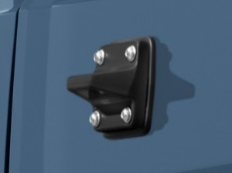

“Unique & Standout” Accessories Set: Enhancing every angle.
  - Spare Tire Cover Garnish Price 4,600 THB
  - Grille Garnish Price 3,400 THB
  - Door Body Molding Price 7,900 THB
  - Door Handle Garnish Price 1,900 THB
  - Side Scuff Plate Price 2,100 THB
  - Rear Door Scuff Plate Price 1,500 THB
  - Fuel Lid Garnish Price 1,200 THB

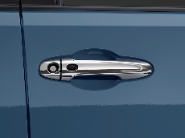
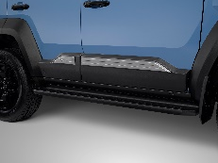
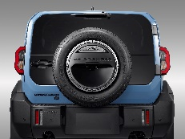

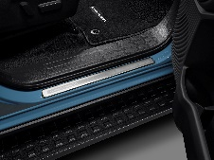
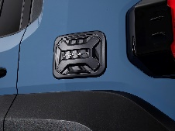
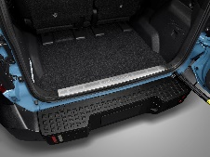

“The Companion” Essential Items: Must-haves for every driver.
- Luggage Tray Price 1,600 THB
- Side Visors Price 2,100 THB
- Door Handle Protective Film (Kevlar Pattern) Price 900 THB

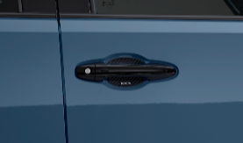
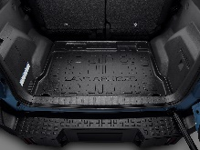

“Vehicle Protection” Items: Making car care easier for enthusiasts.
- Floor Mats Price 1,650 THB
- Car Cover Price 2,750 THB
- Front Sunshade Price 550 THB

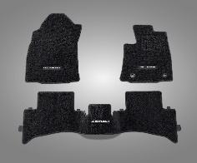
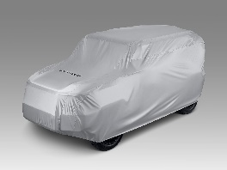
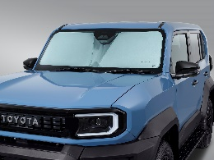

"Capture Every Journey" Accessories: For Peace of Mind in Every Situation
- Front Digital Video Recorder — 2K Price 4,990 THB
- Front Digital Video Recorder — 4K Price 5,990 THB
- Front & Rear Digital Video Recorder — 2K Price 6,000 THB
- Front & Rear Digital Video Recorder — 4K Price 7,000 THB

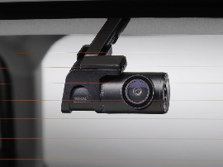
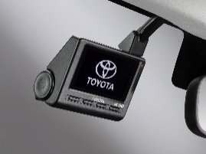

“Peace of Mind” Emergency Items:
- Emergency Kit (Fabric Bag) Price 2,600 THB
- Tire Sealant and Inflator Kit (For large tires) Price 3,200 THB
- Digital Tire Inflator (Version 2) Price 1,700 THB

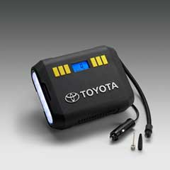
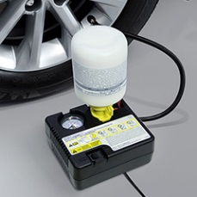
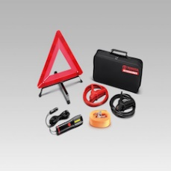

“Wellness & Comfort Drive” Items: Modern must-haves for personal wellness.
- Air Lumbar To Go (Ergonomic Back Support) Price 3,990 THB
- Back Cushion Price 990 THB

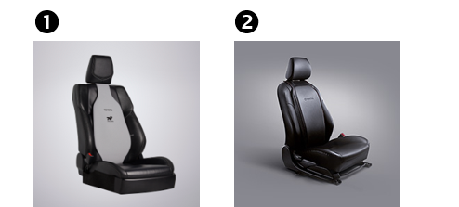

All accessories have been developed under the philosophy of "Enhancing Every Dimension — Beauty and Safety Together," reflecting Toyota's meticulous attention to detail for drivers who want their trusted vehicle ready to tackle any road, every day, with full confidence. Ownership is made even more accessible with the option to include accessories in your monthly installment plan alongside your new vehicle.

Explore the full range of Genuine Toyota Accessories at: https://www.toyota.co.th/accessories/

Notes:

- Recommended retail prices are inclusive of 7% VAT. Installation labor costs are not included.
- Accessories sold through Toyota dealerships are covered under the Genuine Toyota Accessories Quality Warranty of up to 3 years or 100,000 km, whichever comes first (subject to vehicle model as specified by the Company; please refer to the Quality Warranty Manual and Vehicle Owner's Manual for full details)
*For complete warranty details, please visit: https://www.toyota.co.th/accessories/warranty/tga

Design My Toyota: From Idea to Reality
Design My Toyota is Toyota's all-new virtual car customization program, designed to elevate the ownership experience of Toyota vehicles with accessories — making it more convenient and more intuitive than ever. The program features a user-friendly interface with the following functions:

- Vehicle Selection: Select your vehicle model, grade, and color to begin customizing and calculating total costs, including estimated monthly installments.
- Accessories Selection: Personalize your vehicle with Genuine Toyota Accessories and partner accessories across all categories — exterior, interior, electrical, and more — complete with product information to support your decision-making.
- Monthly Installment Calculator: Simulate monthly payment amounts based on your preferred down payment, helping you plan with confidence.
- Save & Share: Save or share your configuration as an image or file with a single click — no login or additional information required.
- Connect to Dealer: Submit your full configuration — vehicle model, accessories, and monthly installment plan — directly to your chosen Toyota dealer to receive a follow-up consultation.

Design My Toyota will be available for all customers to experience and personalize their TOYOTA LAND CRUISER FJ following the official sales launch at:
https://www.toyota.co.th/accessories/designmytoyota

Note: Vehicle images displayed in the Design My Toyota virtual customization program reflect exterior accessories only.

A New Era of Financing with Strategic Partners
Toyota introduces an exclusive campaign tailored for the adventurous lifestyle of Land Cruiser FJ customers. In collaboration with Krungsri Auto and premium motorcycle brand Triumph, this initiative pioneers a new financing solution, unveiled at the Motor Show. Customers can now own both a vehicle and a motorcycle with ease through a combined financing package, with monthly payments starting from just THB 21,743. In addition, customers will receive exclusive privileges, including a Krungsri Gift Card valued at THB 5,000, a Triumph Accessory Voucher valued at THB 5,000, and a Toyota fuel card valued at THB 5,000. This exclusive offer is available from 23 March to 5 April 2026.
*Note: Applicable to selected Triumph motorcycle models only: SPEED 400 / SCRAMBLER 400X / SCRAMBLER 400XC / NEW TRACKER 400.
TOYOTA LAND CRUISER FJ
Exclusive Benefits via TCFR Plus+ / Toyota ALIVE-X and Connect You through the T-Connect Application
The TCFR Plus+ program offers an extended vehicle quality warranty of up to 8 years or 225,000 km (whichever comes first) for customers who bring their vehicle in for scheduled maintenance services. Enrollment is simple — just sign up directly through the T-Connect application. For full details, visit: https://aftersales.toyota.co.th/tcfrplus/

Additionally, customers can enjoy exclusive benefits through the ALIVE-X program, which rewards every service spend at Toyota service centers with The 1 Points, redeemable for discounts at Toyota service centers nationwide. Customers also receive exclusive privileges through the Connect You service, offering special benefits for T-Connect members.

Note: Use of T-Connect services requires downloading the application and obtaining consent from the vehicle owner prior to activation. For full terms and conditions, please visit: www.t-connect.in.th

KINTO — A New Way to Experience the Land Cruiser FJ
Introducing a new alternative to vehicle ownership—drive without buying. KINTO, Toyota’s long-term car subscription service, is designed to meet modern lifestyle needs with a focus on flexibility and value. Enjoy complete peace of mind with a fixed monthly fee throughout the contract, covering comprehensive services including first-class insurance, vehicle maintenance, annual registration and compulsory insurance (CTPL) renewal with home delivery, as well as a replacement vehicle service during maintenance*. Eliminate concerns over future resale value and experience hassle-free mobility with KINTO. For more information and applications, please visit: www.kinto-th.com Note: Terms and conditions apply pas specified by Toyota Leasing (Thailand) Co., Ltd.

