PR. 051/2567
31st July, 2024
Toyota joins IUCN in convening Asia’s conservation community as Forum Partner
for the 8th Asia Regional Conservation Forum
Bangkok, Thailand, 31st July 2024 (IUCN) – Toyota Motor Asia (Thailand) Co. Ltd., a longstanding partner of IUCN (International Union for Conservation of Nature) in mobilizing the business sector for nature and biodiversity conservation, is joining as Forum Partner for the upcoming 8th IUCN Asia Regional Conservation Forum (RCF), to be held in Bangkok, Thailand, from 3-5 September 2024.
Held every four years, the Asia RCF serves as the leading platform for knowledge and partnerships in the region, bringing together key stakeholders in nature and biodiversity conservation. This year, IUCN Asia will convene the 8th RCF to address key transformative directions and actions for achieving a nature positive future for Asia and the world. About 500 representatives of Union constituents, partners and supporters will gather for the three-day event in Bangkok, Thailand.
This partnership for the Asia RCF follows IUCN’s multiple previous engagements with Toyota, which began in 2016 with support for the IUCN Red List of Threatened Species™ at the global level. In Thailand, Toyota has supported the 'Bio-Diversity Network Alliance (B-DNA)' platform since 2018, a network of domestic and multinational companies aimed at learning new biodiversity trends and sharing best practices related to sustainability. Under the B-DNA, Toyota and IUCN Asia co-hosted the Bang Pu coastal cleanup and mangrove plantation together with 14 companies in 2019, to kick-start efforts to tackle plastic pollution, encourage afforestation and raise awareness on biodiversity conservation.
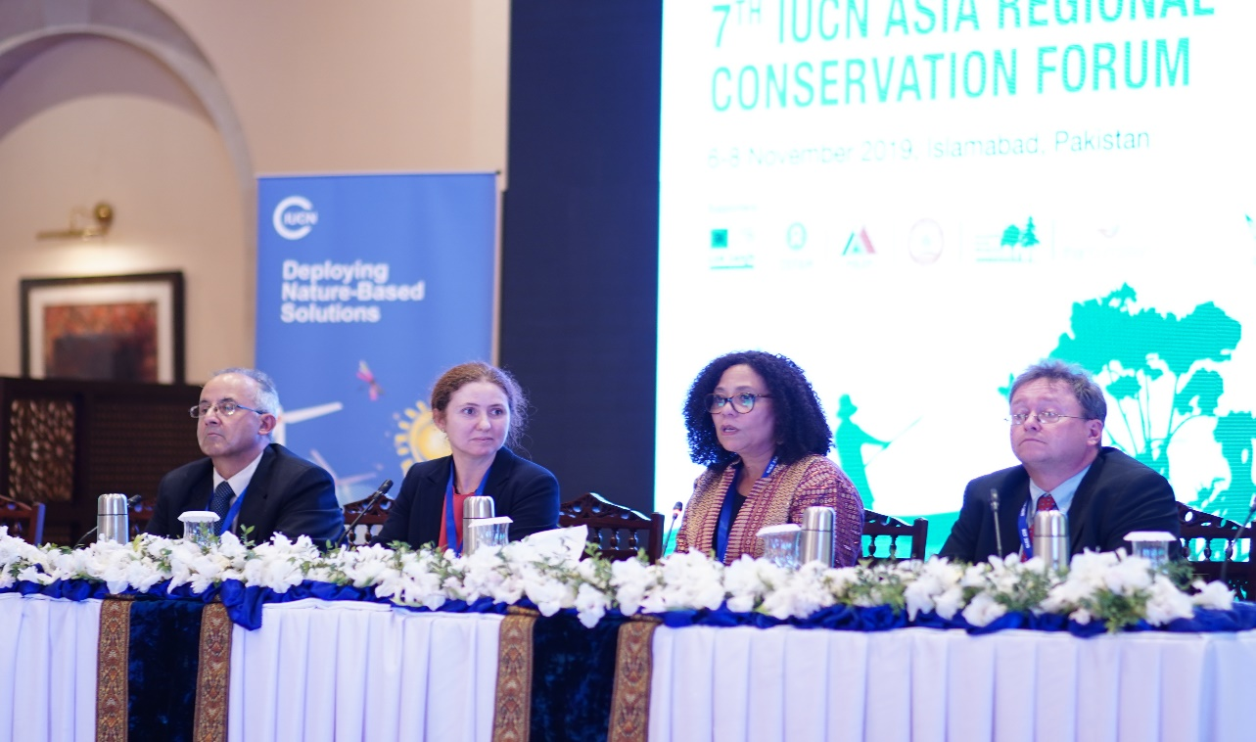 The 7th IUCN Asia Regional Conservation Forum in Pakistan

“We greatly value Toyota’s initiative in championing business for biodiversity in Asia and beyond. As an RCF partner, Toyota helps provide a convening platform to showcase our over eight years of collaboration. We hope this partnership will lay the groundwork for even more public-private collaborations across the region following the RCF,” said Dr. Dindo Campilan, IUCN Regional Director for Asia and Hub Director for Oceania. The Forum Partner category is the highest level of the four sponsorship types available at the Asia RCF, providing Toyota with extensive opportunities for recognition before and during the event.
“Toyota is committed to its mission to safeguard resources and manage its ecological footprint, aiming for a healthier planet for the next generations with a legacy of environmental stewardship since the 1960s. The Toyota Environmental Challenge (TEC) 2050, formulated in 2015, encapsulates our dedication to biodiversity, species protection, and habitat restoration. In partnership with IUCN and the Asia RCF, we aim to bring stakeholders together to advance biodiversity conservation with effective and immediate solutions,” said Mr. Pras Ganesh, Executive Vice President of Toyota Motor Asia (Thailand) Co., Ltd.
The TEC 2050 is a set of six visionary, global challenges that seek to go beyond eliminating negative environmental impacts to creating positive value for the planet and society. It lays out Toyota’s holistic and practical approach to find new ways to tackle impacts on the air, water, materials and biodiversity, through key partnerships and outreach. It includes the Multiple Pathway approach that offers a diverse range of low and zero-emission mobility solutions designed to meet specific regional realities and customer mobility needs. These initiatives pledge to significantly reduce CO2 emissions and achieve global carbon neutrality across all our vehicles and operations by 2050.
The 8th IUCN Asia Regional Conservation Forum is co-organised with the National Committee of IUCN Members in Thailand and co-hosted by the Ministry of Natural Resources and Environment, Government of Thailand, under the theme ‘Reimagining Conservation in Asia: A Nature Positive Future.’ The RCF serves as a precursor to the 2025 IUCN World Conservation Congress, providing a platform for regional stakeholders to discuss key priorities and influencing the global event’s agenda.
RCF registration for non-media participants is open until 15 August. Please access the registration form from this link (https://civicrm.iucn.org/event/asiarcf). For media representatives, a separate advisory will be sent in early August with registration procedure. Please send an email to kosuke.terai@iucn.org should you like to receive the media advisory.

- About IUCN
IUCN is a membership Union uniquely composed of both government and civil society organisations. It provides public, private and non-governmental organisations with the knowledge and tools that enable human progress, economic development and nature conservation to take place together.

Created in 1948, IUCN is now the world’s largest and most diverse environmental network, harnessing the knowledge, resources and reach of more than 1,400 Member organisations and around 16,000 experts. It is a leading provider of conservation data, assessments and analysis. Its broad membership enables IUCN to fill the role of incubator and trusted repository of best practices, tools and international standards.

IUCN provides a neutral space in which diverse stakeholders including governments, NGOs, scientists, businesses, local communities, indigenous peoples’ organisations and others can work together to forge and implement solutions to environmental challenges and achieve sustainable development.

Media contact: Kosuke Terai, Stakeholder Engagement and Communications Officer, IUCN Asia Regional Office (kosuke.terai@iucn.org)

- About Toyota Motor Asia
Toyota Motor Asia is a subsidiary of Toyota Motor Corporation and the regional corporate headquarters for the Asia Region, with offices in both Singapore and Thailand.
Toyota Motor Asia leads and supports the Asia Pacific region in Research & Development, Product and Business Planning, Production Control & Logistic, Sales and Marketing activities, Customer First and Aftersales, thus contributing to the overall development of the auto industry and thereby the economies and quality of life of those involved in the region.
Toyota envisions a future mobility society that realizes freedom of movement to all while pursuing carbon neutrality. Moving forward, Toyota will provide a diverse range of low and zero carbon services and solutions through the integration of energy, mobility and data, contributing to people and the planet as we transform Toyota into a mobility company.
Media contact: Jidapa Kaewyoungjit, Environmental Affairs Project Manager, Toyota Motor Asia Regional Office (jidapa_kae@toyota-asia.com)

--ends--

