Product Information
TOYOTA LAND CRUISER FJ
“Bold & Unbound…Be Defined, Go Beyond”

The TOYOTA LAND CRUISER FJ is available for ownership in 3 color options:

        - New! SMOKY BLUE
        - PLATINUM WHITE PEARL MICA
        - ASH

TOYOTA LAND CRUISER FJ — TECHNICAL SPECIFICATIONS
Length (mm) | 4,610
Width (mm) | 1,855
Height (mm) | 1,890
Wheelbase (mm) | 2,580
Engine Code | 2TR-FE
Engine Type | Inline 4-Cylinder DOHC 16-Valve with Dual VVT-i
Displacement | 2,694 cc
Bore x Stroke | 95 x 95 mm
Maximum Power kW (PS) / rpm | 122, (166) / 5,200
Maximum Torque Nm / rpm | 245 / 4,000
Transmission | 6-Speed Automatic
Drivetrain | Part-Time 4WD with Rear Differential Lock (Rear Diff – Lock)
Fuel Compatibility | Gasohol 91, 95 and E20

1. EXTERIOR DESIGN
Blending the “PLAYFUL-DICE” concept with “FUNCTIONAL BEAUTY,” reflecting the unique identity of the LAND CRUISER through strength, fun, and practicality.
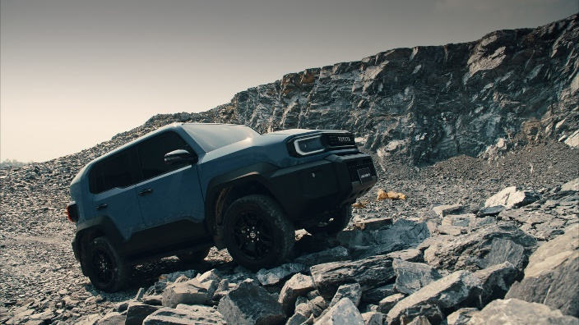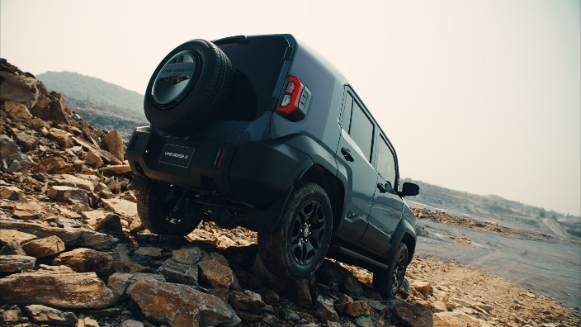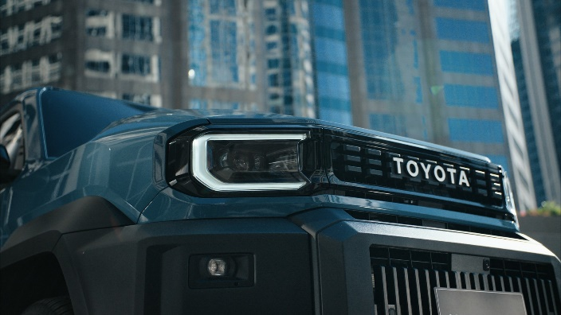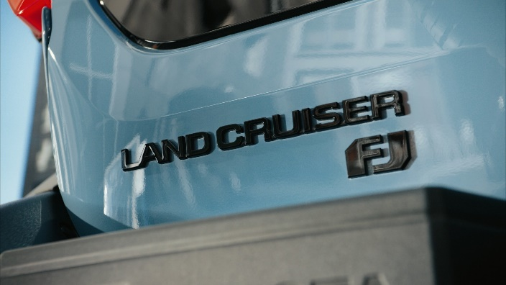

- Boxy body design with chamfered edges and streamlined corners to eliminate unnecessary volume, preserving the Land Cruiser identity while enhancing on- and off-road agility.
- Excellent driving visibility achieved through a low beltline and a centrally sculpted hood center.
- 3-piece modular front and rear bumpers designed for easy replacement, helping to reduce maintenance costs.
- Side body moldings to protect against scratches during use and ensure easy repair.
- LED Projector Headlamps with Daytime Running Lights (DRL) and LED Fog Lamps.
- LED Rear Combination Lamps with bulb-type turn signals and LED Fog Lamps.
- Spare tire mounted on the tailgate with wheel cover
- Rugged wheel arch design for a bold, muscular stance, paired with 18-inch black alloy wheels and 265/60 R18 tires
- Side-opening tailgate for enhanced utility and versatility.

2. INTERIOR DESIGN & CONVENIENCE
Designed under the “FUNCTIONAL FUN COCKPIT” concept to ensure ease of use and deliver a superior driving experience.

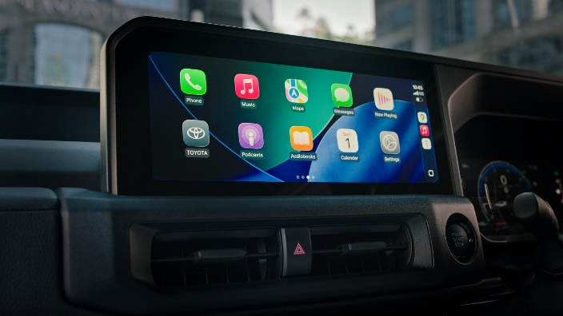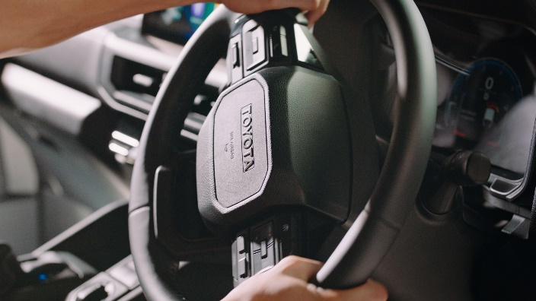
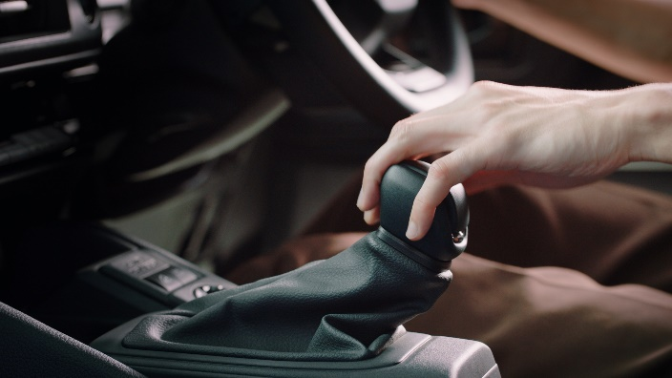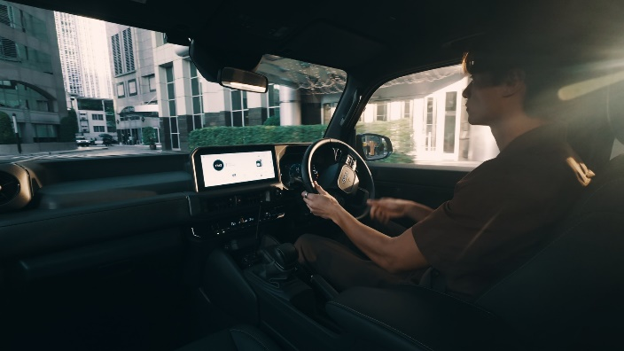

- Center console and steering wheel-mounted controls positioned within easy reach for safe and effortless operation
- Steering wheel with wide-gap spokes to minimize the risk of injury from "kickback" during off-road maneuvers.
- Ample headroom providing a spacious and airy cabin feel.
- Black synthetic leather seats for all 5 positions.
- Durable interior materials that are easy to maintain, specifically selected for rugged and heavy-duty use.
- 8-way power-adjustable driver’s seat.
- 2nd-row split-folding seat (55:45)with 5-position fore-and-aft sliding adjustment for flexible passenger and cargo configurations, and 40-degree recline for enhanced passenger comfort
- Luggage capacity of 765 liters, expandable to 1,522 liters when all seats are folded.
- 12.3-inch touchscreen audio system supporting Wireless Apple CarPlay and Android Auto with a 6-speaker system.
- 7-inch Multi-Information Display (MID) featuring a Clinometer (displaying vehicle pitch and roll angles).
- Dual-zone automatic climate control (independent left-right adjustment).
- One-touch power windows for all four doors.
- Push-button engine start system

3. 2TR-FE 2.7L GASOLINE ENGINE
A time-proven, highly durable engine meeting Euro 6 emission standards, delivering 166 PS of maximum power and 245 Nm of peak torque.
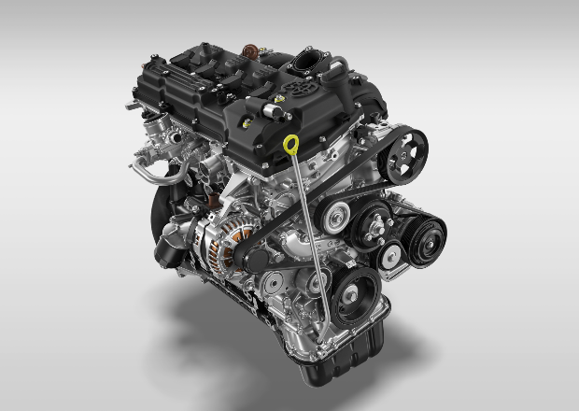

- Continuously developed and optimized for demanding 4WD applications
- Paired with a 6-speed Automatic Transmission, delivering responsive and seamless power in both on-road and off-road conditions.

4. BODY-ON-FRAME CONSTRUCTION — SHARED PLATFORM WITH HILUX CHAMP SSWB
Engineered with reinforced rear structural enhancements to meet Land Cruiser safety and performance standards.
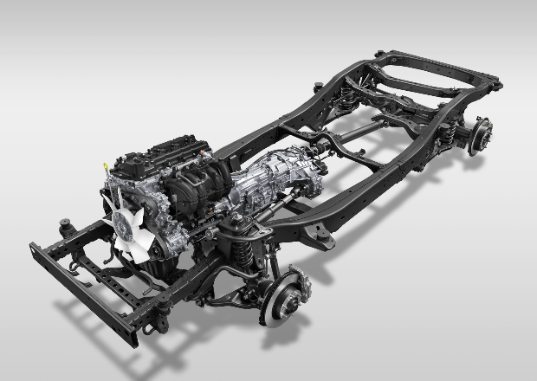

- Reinforced rear side rails through optimized frame length reduction for enhanced structural rigidity
- Additional weld points at the rear suspension mounts to ensure superior structural rigidity and durability in accordance with LAND CRUISER standards.
- Under-engine skid plate added for structural protection and confident driving across all terrain
- Reinforced cross-members and rear axle to support the 4WD system and increase versatility for accessory installation or towing.
- Strategic weight distribution contributes to a low center of gravity (Low CG), resulting in reduced body roll and enhanced stability, handling, and road-holding performance.
- Reinforced rear towing hitch integrated directly into the frame for maximum durability.

5. DRIVETRAIN, SUSPENSION, BRAKING & STEERING
Engineered for confident off-road performance, delivering agility and capability across the most challenging terrain
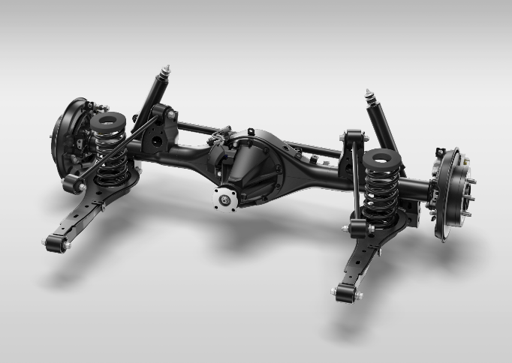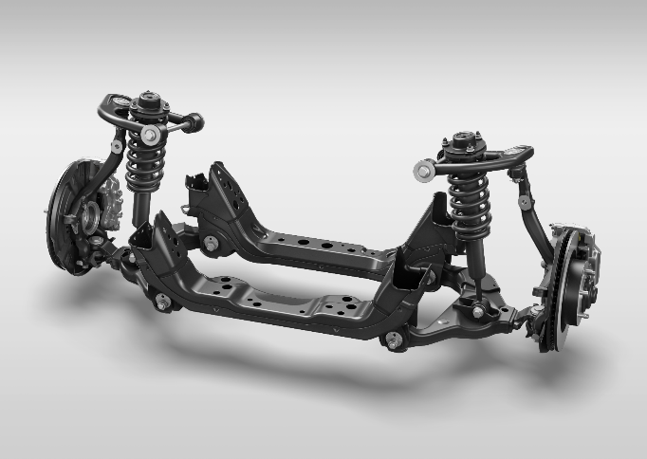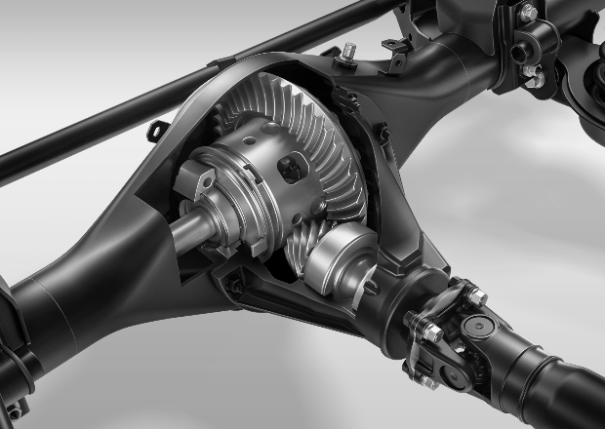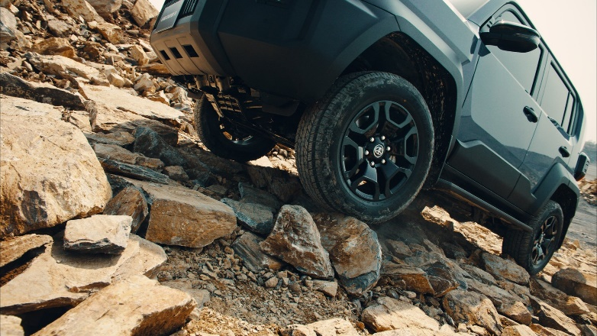

- Part-time 4WD system with Rear Differential Lock (Rear Diff-Lock) to ensure equal power distribution to both rear wheels.
- 2nd Start Mode to minimize wheel spin and assist in smooth take-offs on slippery surfaces.
- High approach and departure angles with a tight turning radius and a 700 mm wading depth.
- Front Suspension: Independent Double Wishbone with coil springs and stabilizer bar.
- Rear Suspension: 4-Link with coil springs and stabilizer bar.
- Newly tuned shock absorbers and coil springs to minimize body roll, enhance stability, and provide excellent ride comfort.
- Braking System: Ventilated disc brakes (Front 17” / Rear 15”).
- Hydraulic Power-Assisted Rack & Pinion Steering.
- Large-diameter steering shaft to minimize vibration transmission, ensuring precise and responsive steering control.
- Optimized ECU tuning for engine, transmission, and throttle response tailored for peak off-road performance.
- Short wheelbase for high maneuverability and ease of driving.
- High breakover angle—achieved by positioning the lowest chassis point closer to the wheels—to clear steep obstacles without 'high-centering.

6. COMPREHENSIVE SAFETY SYSTEMS
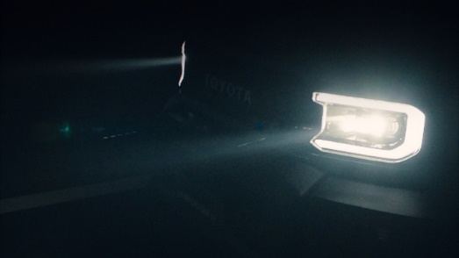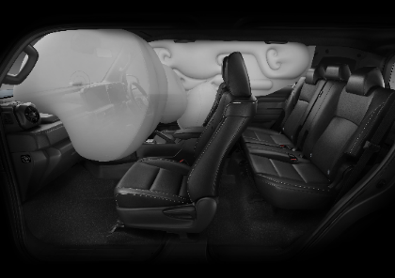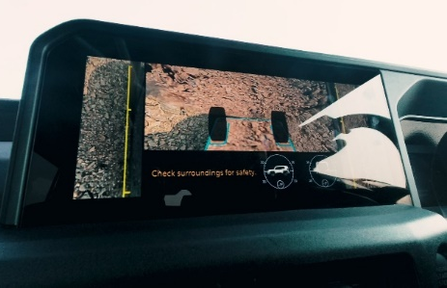
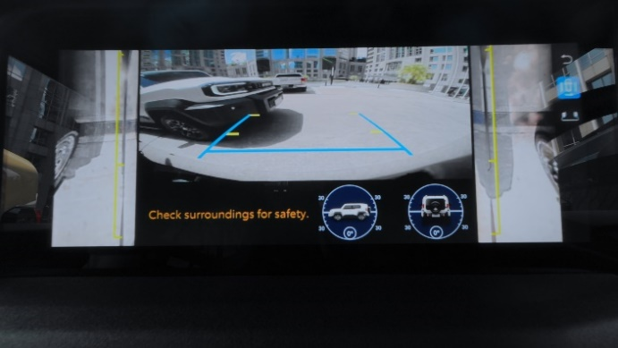

- Toyota Safety Sense (TSS)
  - Adaptive High-beam System (AHS)
  - Dynamic Radar Cruise Control (DRCC)
  - Pre-Collision System (PCS)
  - Lane Departure Alert (LDA)
- Panoramic View Monitor (PVM) in HD resolution, featuring pitch/roll display and Underfloor View.
- Pretensioner and force-limiter seatbelts (front and outer rear).
- 7 SRS Airbags.
- Blind Spot Monitor (BSM)
- Rear Cross Traffic Alert (RCTA) with automatic braking.
- Parking Support Brake (PKSB) — alerts for moving vehicles and applies automatic braking upon detection of stationary objects
- Hill Start Assist Control (HAC)
- Downhill Assist Control (DAC)
- Active Traction Control (A-TRC)

